GOVERNMENT COLLEGE OF ENGINEERING [IRTT]

**ERODE: 638 316**



Electronics and Communication Engineering

**NAAN MUDHALVAN DIGITAL MARKETING ASSIGNMENT**

NM ID: B773CDDBA4CD1FD9C2C418BF6417FA6E

NAME: SANJAY S

BRAND NAME**: DOSS SOFTDRINKS**

CATEGORY**: SOFTDRINKS MANUFACTURER**

1. Create a blog or website using Blogspot and WordPress. Customize the theme design and post new article with 500 words.

Link: Blog using Blogspot <https://dosssoftdrinks.blogspot.com/2023/10/doss-softdrinks.html>

Screenshots:

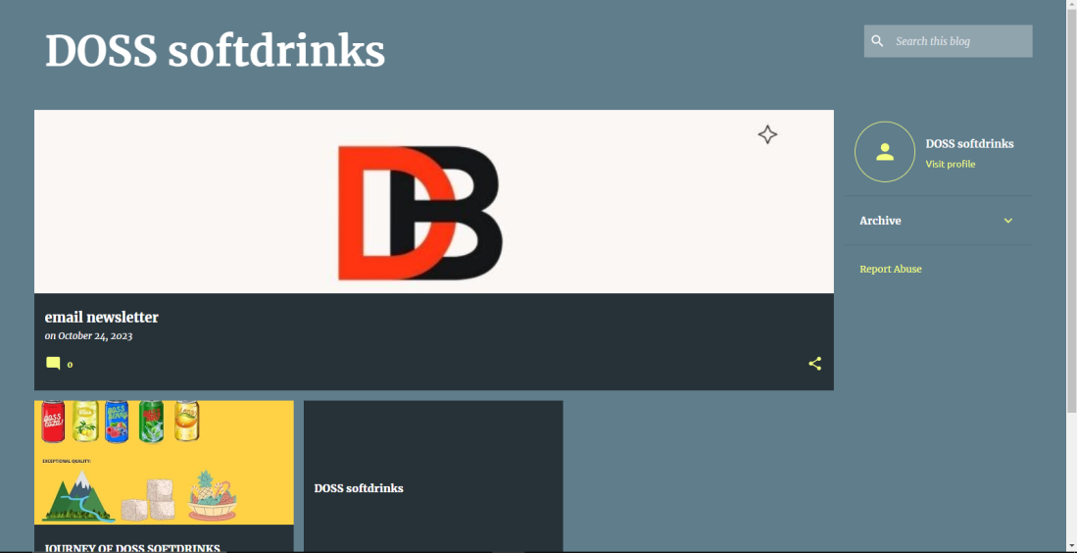

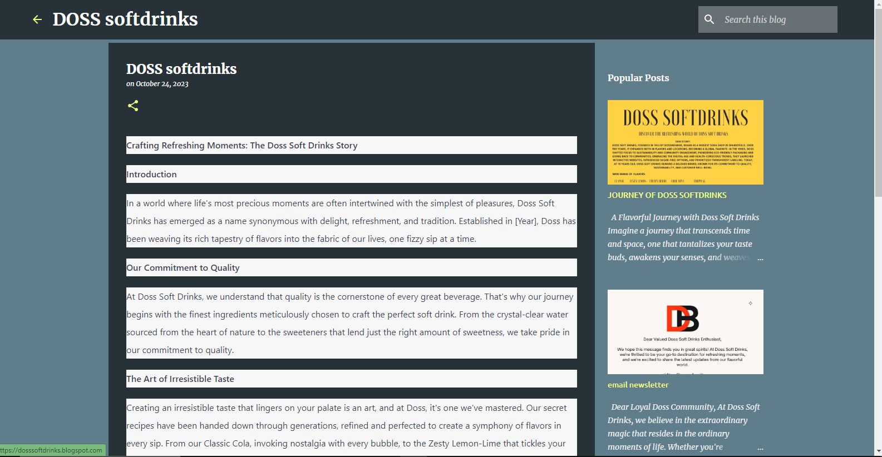

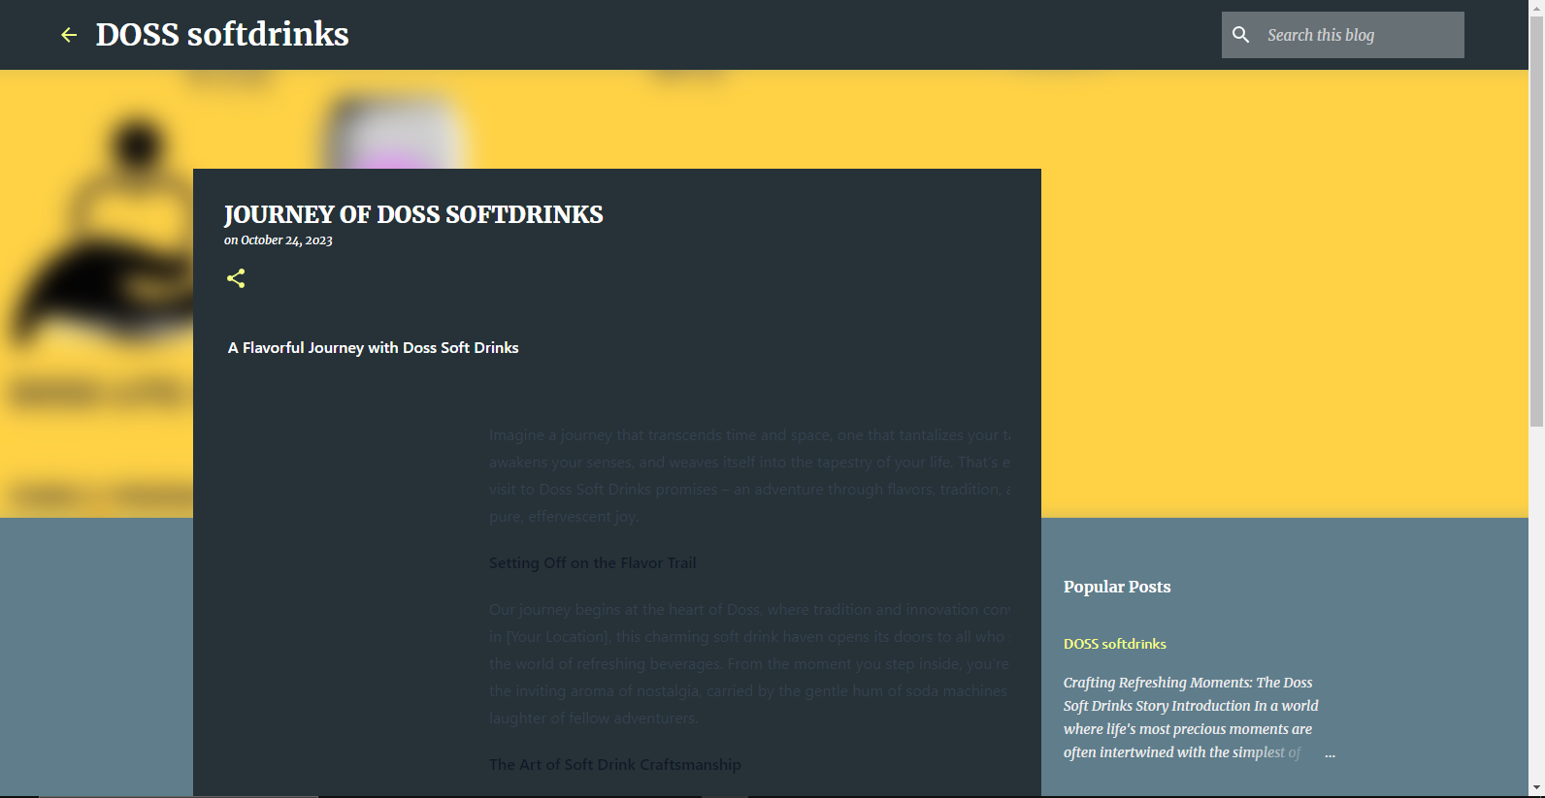

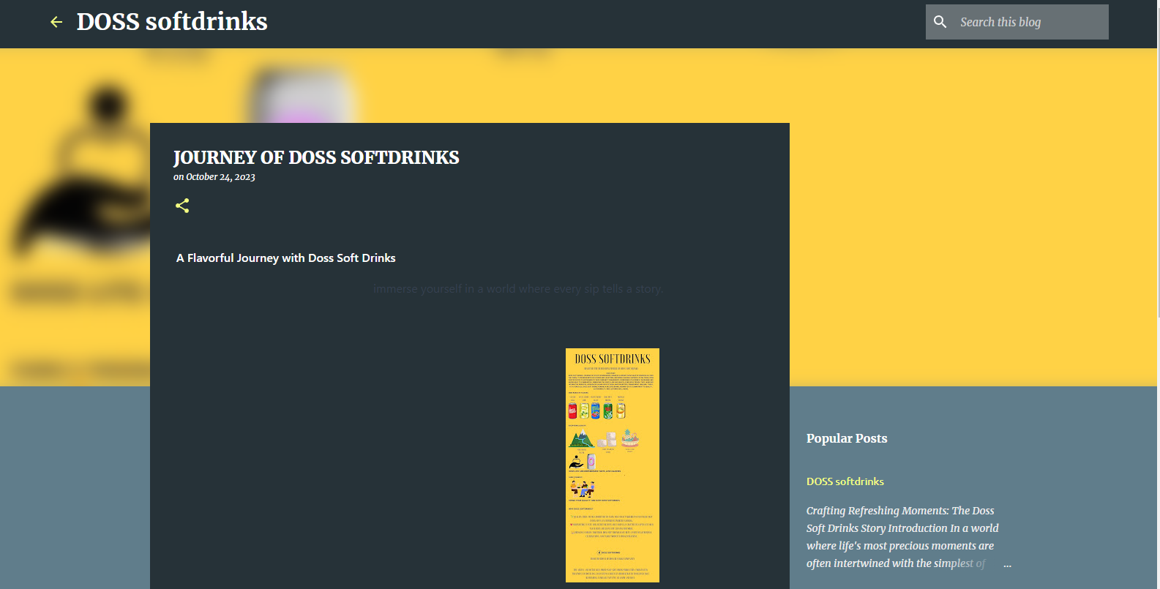

1. Create a New Facebook Business Page and post one social media poster for your brand.

Link: Facebook business page

[https://www.facebook.com/Dosssoftdrinks](%20https:/www.facebook.com/Dosssoftdrinks)

Screenshots:

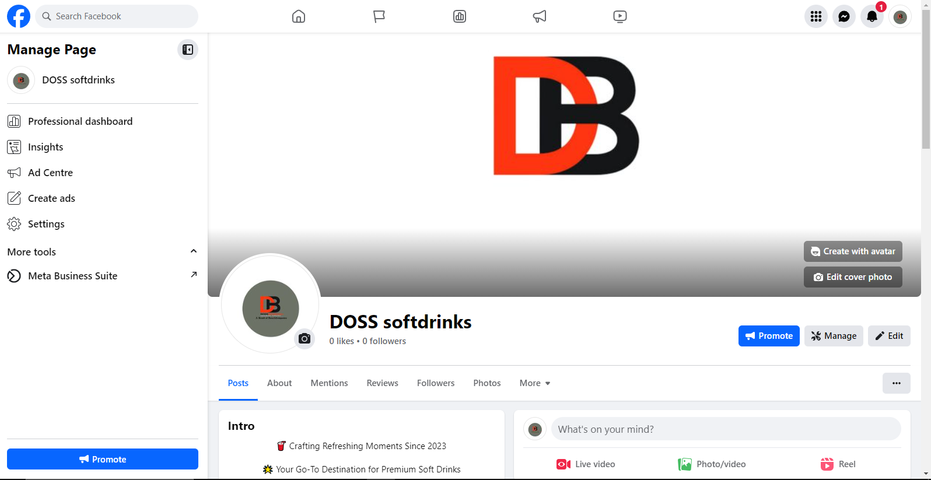

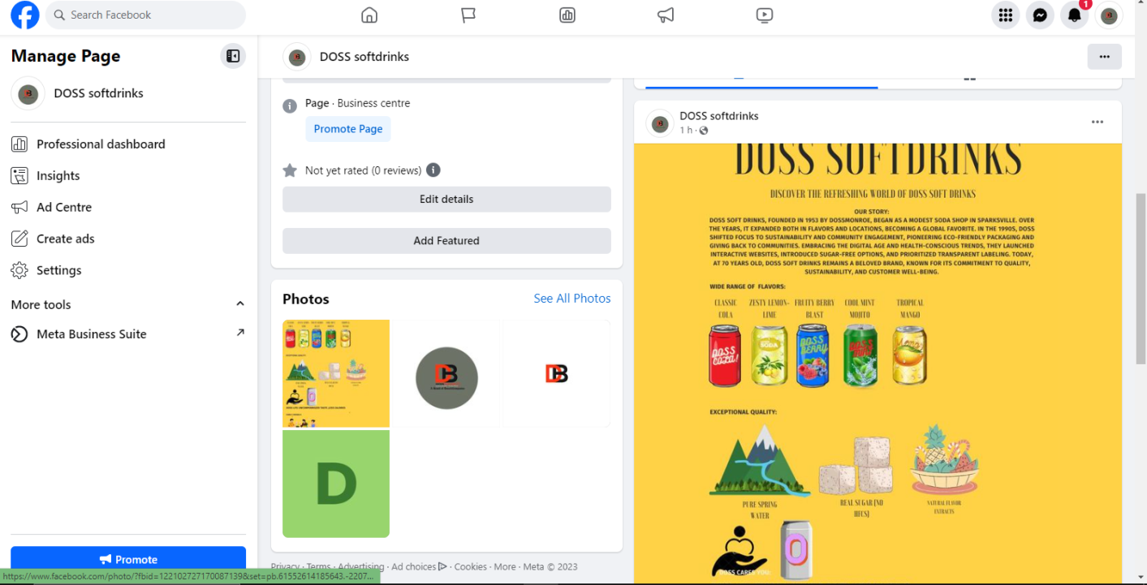

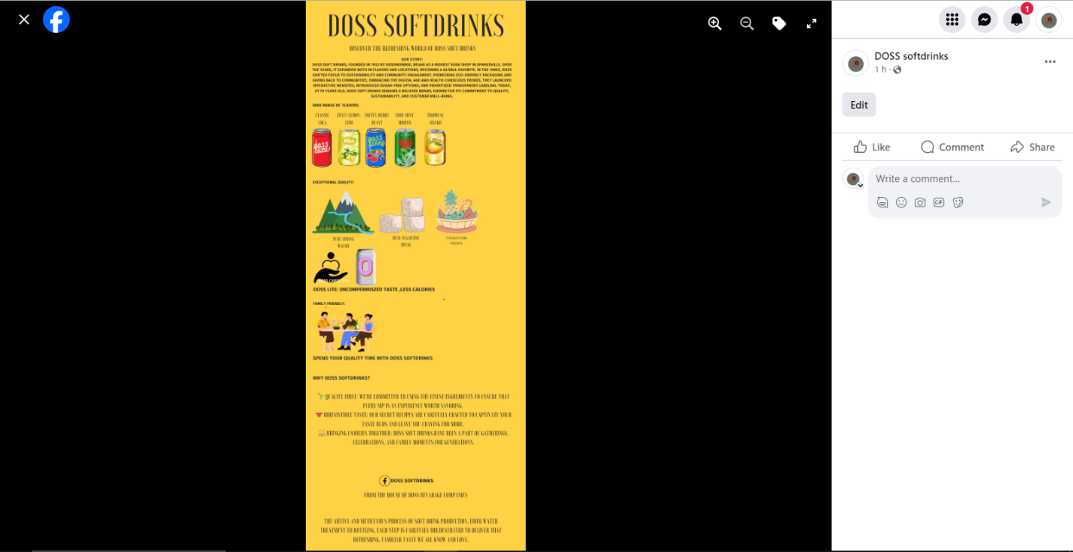

1. Create and design a social media advertisement poster using canva.

Link: Infographics Page Design using canva <https://dosssoftdrinks.blogspot.com/2023/10/journey-of-doss-softdrinks.html>

Screenshots:





1. Create email newsletter design using MailChimp or canva tool.

Link: Email newsletter design using canva <https://dosssoftdrinks.blogspot.com/2023/10/email-newsletter.html>

Screenshots:

